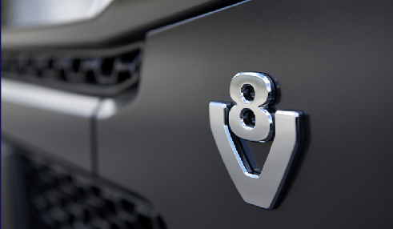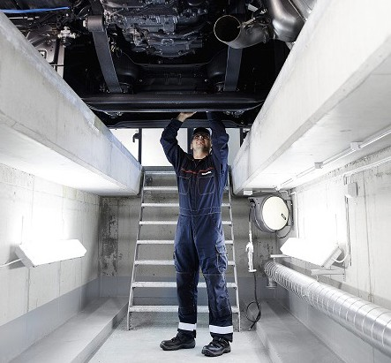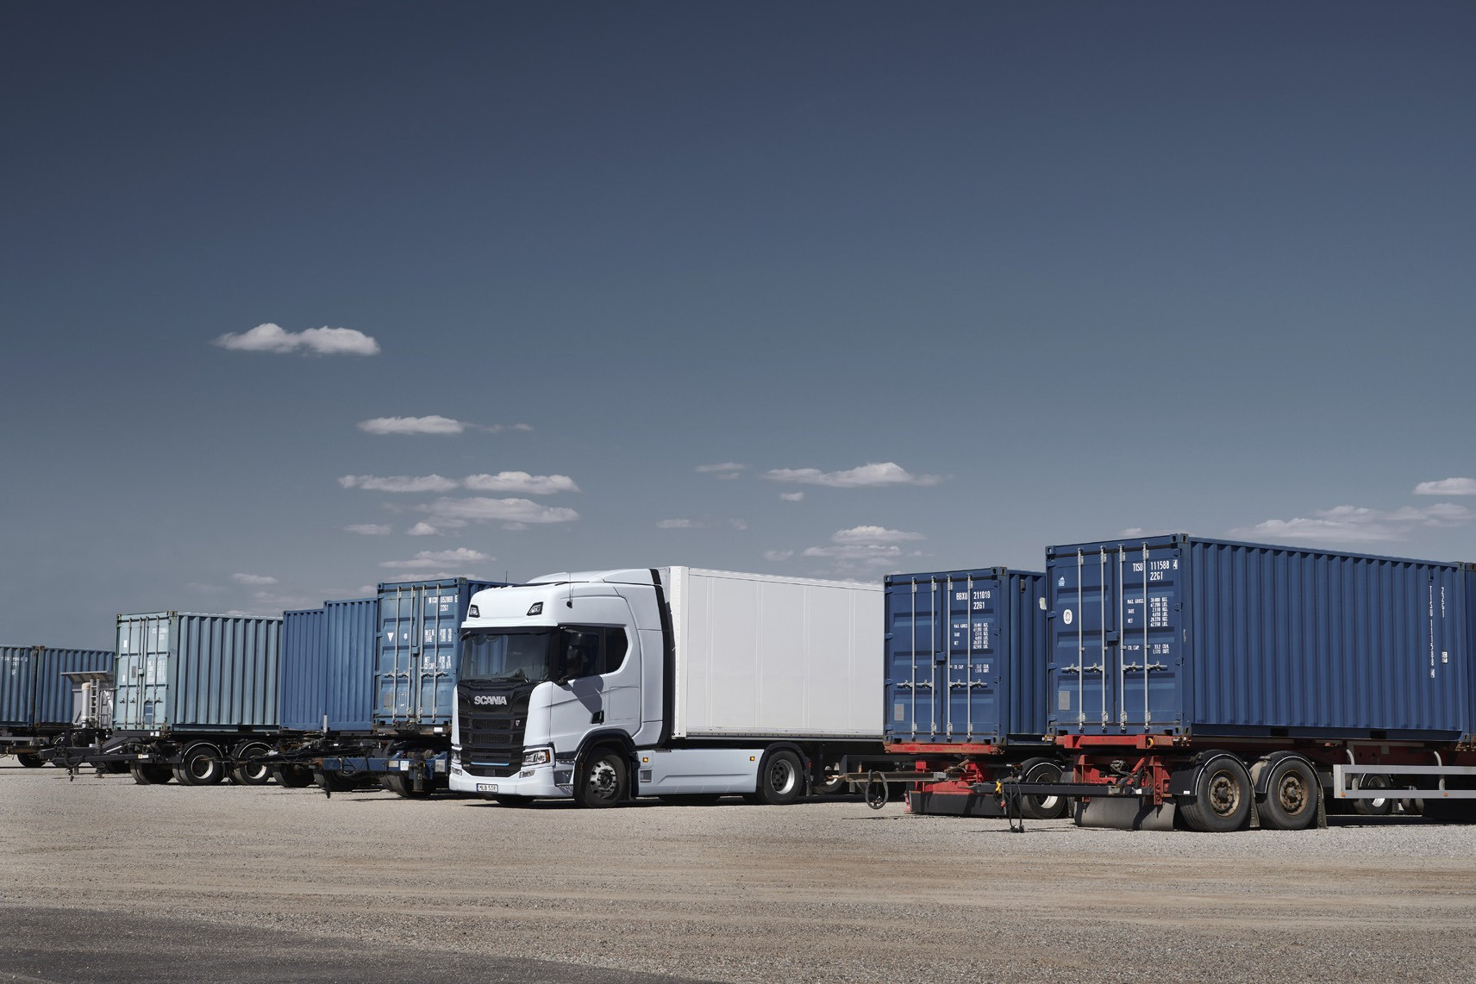

HGV Technician - nights

**Middleton**

**WK1: 6:00PM – 4:00AM / WK2: 8:00PM – 6:00AM (TUES – FRI)**

**Up to £25.12 Per Hour**

**Benefits:**

**• World Class Scania Training to support career progression**

**• Overtime available, all paid at 1.5 times hourly rate**

**• Company Pension**

**• Company Life Insurance**

**• Cycle to work scheme**

**• Gym Discount scheme offering 70% off gym membership**

**• Healthcare cash Plan**

**• Generous referral programme**

**• Rewards scheme offering cashback and store discounts**

West Pennine Trucks is one of six independent dealer’s groups across the Scania network and has held a Scania franchise since 1986. It is the

North West’s largest privately owned, authorised Scania dealer group and covers the industrial areas of Greater Manchester down into the more rural counties of Cheshire, Staffordshire, Shropshire and mid-Wales.

If you want to learn more about us, click here: West Pennine Trucks - Careers

[**www.westpenninetrucks.com**](http://www.westpenninetrucks.com)